1. Write a Java program that reads data from a sample.txt file located outside the program’s directory.

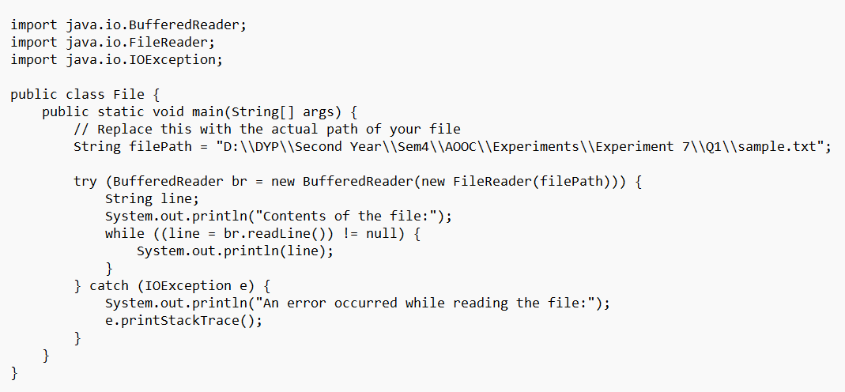

1. Develop a Java program that performs the following operations: ○ Accept student information such as name, age, weight, height, city, and phone number from the user. ○ Store this information in a file using DataOutputStream along with FileOutputStream.  
   ○ Retrieve and display the data using DataInputStream along with FileInputStream.

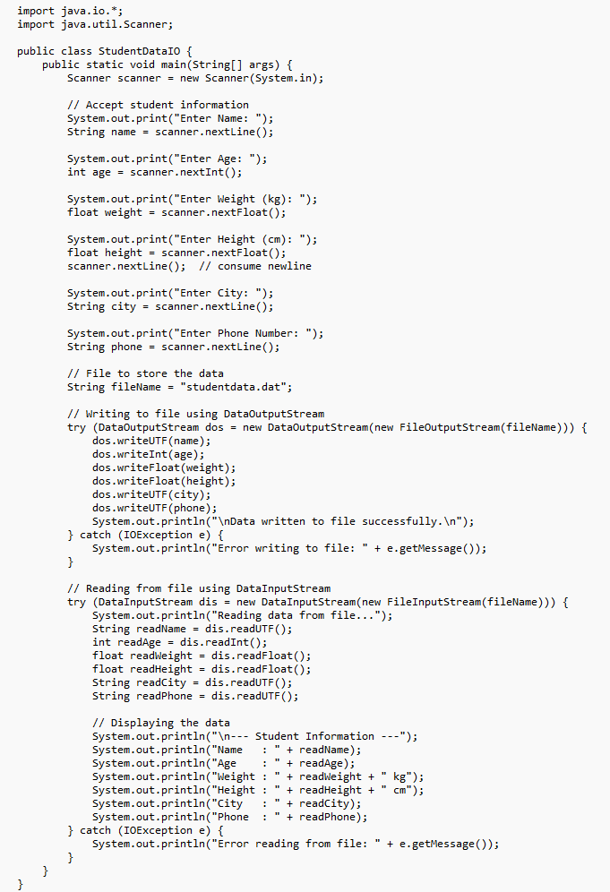

1. Write a Java program to read a text file and compute the following: ○ The total number of vowels in the file. ○ The total number of words in the file. ○ The number of times the character 'a' appears in the file.

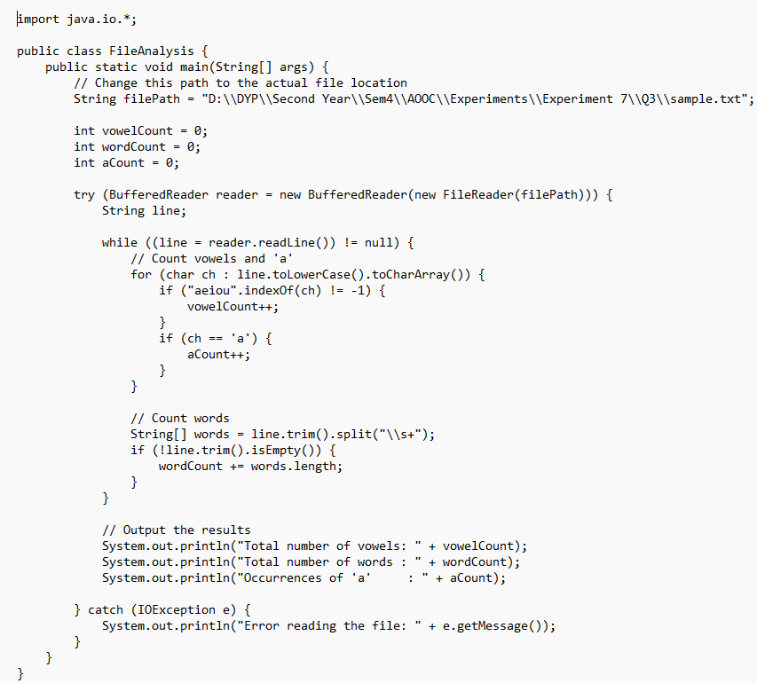

Write a program that takes a file name as input through the command line. ● If the file exists, open it and display its contents. ● After displaying the contents, ask the user: “Do you want to add data to the end of the file?” ● If the user's response is "Yes", accept data from the user and append it to the file. ● If the file does not exist, create a new file and allow the user to input data to store in it. ● The user should type “exit” on a new line to stop entering Implement this program using character stream classes. 